**Project Design Phase-II**

**Technology Stack (Architecture & Stack)**

|  |  |
| --- | --- |
| Date | 09 November 2022 |
| Team ID | PNT2022TMID51917 |
| Project Name | Project – Personal Expense Tracker |
| Maximum Marks | 4 Marks |

**Technical Architecture:**

The Deliverable shall include the architectural diagram as below and the information as per the table1 & table 2

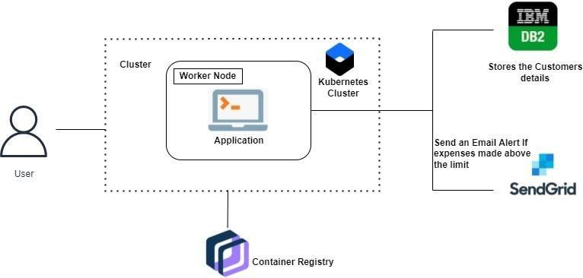

**Table-1 : Components & Technologies:**

|  |  |  |  |
| --- | --- | --- | --- |
| **S.No** | **Component** | **Description** | **Technology** |
|  | User Interface | The user can Interact with the application with use of Chatbot | HTML, CSS, JavaScript / Angular Js / React Js etc. |
|  | Application Logic-1 | The application contains the sign in/sign up where the user will login into the main dashboard | Java / Python |
|  | Application Logic-2 | Dashboard contains the fields like  Add income, Add Expenses, Save  Money | IBM Watson STT service |
|  | Application Logic-3 | The user will get the expense report in the graph form and also  get alerts if the expense limit  exceeds | IBM Watson  Assistant,SendGrid |
|  | Database | The Income and Expense data are stored in the MySQL database | MySQL, NoSQL, etc. |
|  | Cloud Database | With use of Database Service on Cloud, the User data are stored in a well secured Manner | IBM DB2, IBM Cloudant etc. |
|  | File Storage | IBM Block Storage used to store the Financial data of the user | IBM Block Storage or Other  Storage Service or Local  Filesystem |
|  | Application Logic-1 | The application contains the sign in/sign up where the user will login into the main dashboard | Java / Python |
|  | Application Logic-2 | Dashboard contains the fields like  Add income, Add Expenses, Save  Money | IBM Watson STT service |
|  | Application Logic-3 | The user will get the expense report in the graph form and also  get alerts if the expense limit  exceeds | IBM Watson  Assistant,SendGrid |
|  | Database | The Income and Expense data are stored in the MySQL database | MySQL, NoSQL, etc. |

**Table-2: Application Characteristics:**

| **S.No** | **Characteristics** | **Description** | **Technology** |
| --- | --- | --- | --- |
|  | Open-Source Frameworks | Flask Framework in Python is used to implement this Application | Python-Flask |
|  | Security Implementations | This Application Provides high security to the user Financial data. It can be done by using the  Container Registry in IBM cloud | Container Registry, Kubernetes Cluster |
|  | Scalable Architecture | Expense Tracker is a life time access supplication. It’s demand will increase when the user’s  income are high | Container Registry, Kubernetes Cluster |
|  | Availability | This application will be available to the user at any part of time | Container Registry, Kubernetes Cluster |
|  | Performance | The performance will be high because there will be no network traffics in the application | Kubernetes Cluster |